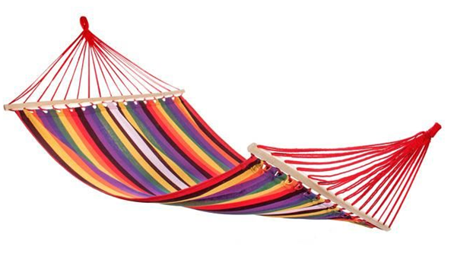

hamak



Hubert

|  |  |  |  |  |
| --- | --- | --- | --- | --- |
| h | a | m | a | k |

|  |  |  |  |  |  |
| --- | --- | --- | --- | --- | --- |
| H | u | b | e | r | t |

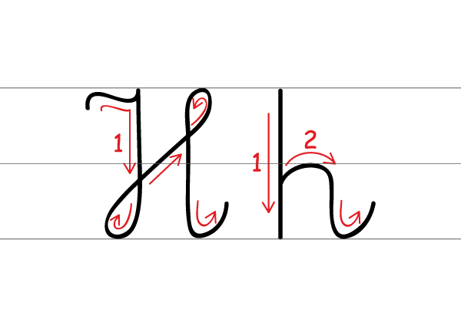

H h